🔧 What Does a Parser Do?
# Source: AI Source: Provided by: [Data Path: Persons Table -> ID Column: 1, Name_En Column: Motasem Essam] -> From: [Chatgpt (GPT‑5 Mini)] on [12/9/2025]
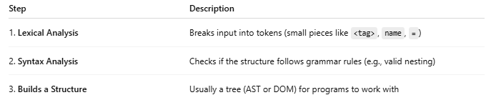
Step | Description
1. Lexical Analysis | Breaks input into tokens (small pieces like <tag>, name, =)
2. Syntax Analysis | Checks if the structure follows grammar rules (e.g., valid nesting)
3. Builds a Structure | Usually a tree (AST or DOM) for programs to work with

